
BBQ Rangehood
Instruction and Installation Manual
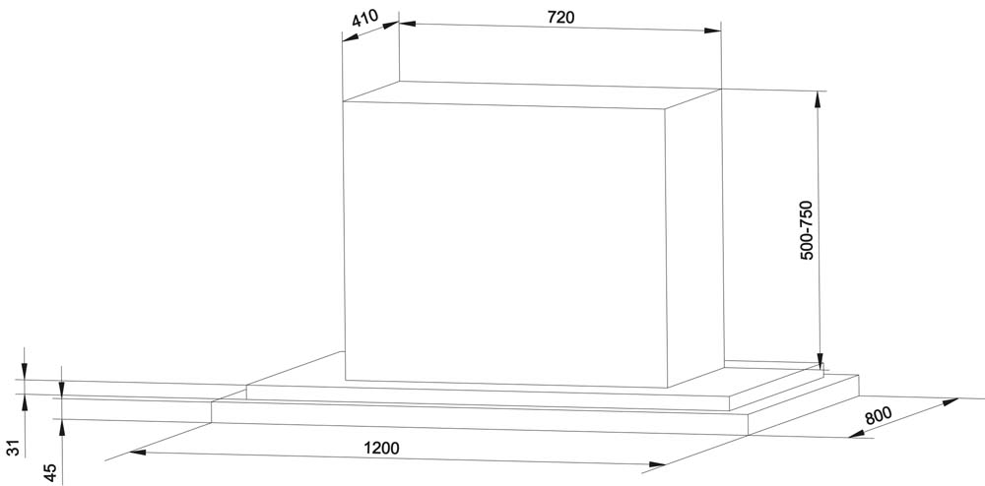
Model EASIAIR 1200MI ISLAND

IMPORTANT:
Read and save these instructions
Installer: Leave this guide with the homeowner
Homeowner: Keep this guide for future reference

TABLE OF CONTENTS

BEFORE YOU START PAGE 3
WARNING PAGE 3
BEFORE USE PAGE 3-5
PREPERATION PAGE 6
SUPPLIED MATERIALS PAGE 7
VENTING REQUIREMENTS PAGE 7
VENTING METHODS PAGE 8
INSTALLATION PAGE 9
ELECTRICAL REQUIREMENTS PAGE 10
RANGEHOOD OPERATION PAGE 11
CLEANING PAGE 12
SPECIFICATIONS PAGE 12
TROUBLE SHOOTING PAGE 13
WARRANTY PAGE 14

BEFORE YOU START

Your safety and the safety of others is very important. We have provided many important safety messages in this manual and on your appliance. Always read and obey all safety messages. All safety messages will tell you what the potential hazard is, tell you how to reduce the chance of injury, and tell you what can happen if the instructions are not followed.

WARNING!

Below is the safety alert symbol. This symbol alerts you to potential hazards that can hurt you and others. All safety messages will follow the safety alert symbol and the word “WARNING”


BEFORE USE

- There shall be adequate ventilation of the room when the range hood is used at the same time as appliances burning gas or other fuels.
- Clean the range hood every week – there is a fire risk if cleaning is not carried out in accordance with the instructions;
- CAUTION: Accessible parts may become hot when used with cooking appliances.
- The air must not be discharged into a flue that is used for exhausting fumes from appliances burning gas or other fuels;
- The minimum distance is 120 cm between the supporting surface for the cooking surface on the hob and the lowest part of the range hood.
- Regulations concerning the discharge of air have to be fulfilled. Ducting must be connected to an outside flue.
- When the range hood and appliances supplied with energy other than electricity are simultaneously in operation, the negative pressure in the room must not exceed 4 Pa (4 x 10-5 bar).

Attention! Observe the warning in the instruction sheet concerning the operation of the appliance when air is discharged from the room. The rangehood is only designed for domestic use. Use in a commercial application will void the warranty.

WARNING: To reduce the risk of fire or electric shock, do not use this fan with any solid-slate speed control device.
WARNING: To reduce the risk of fire, use only metal ductwork.
CAUTION: For general ventilating use only. Do not use to exhaust hazardous or explosive materials and vapors.

TO REDUCE THE RISK OF FIRE, ELECTRIC SHOCK, OR INJURY PLEASE READ THE FOLLOWING:

- Use this unit only in the manner intended by the manufacturer, if you have questions, contact the manufacturer.
- Before servicing or cleaning unit, switch power off at service panel and lock service disconnecting means, to prevent power from being switched on accidentally. When the service disconnecting means cannot be locked, securely fasten a prominent warming device, such as a tag, to the service panel.
- Installation work and electrical wiring must be done by qualified person(s) in accordance with all applicable codes and standards, including fire-rated construction. If unit is installed by unqualified tradesperson, warranty will be void.
- Sufficient air is needed for proper combustion and exhausting of gases through the flue (chimney) of fuel burning equipment to prevent back drafting. Follow the heating equipment manufacturer’s guideline and safety standards such as those published by Energy Safe Australia and the local authorities.
- When cutting or drilling into wall or ceiling, do not damage electrical wiring and other hidden utilities. Ducted fans must always be vented to the outdoors.

TO REDUCE THE RISK OF A RANGE HOOD GREASE FIRE, READ BELOW

- Never leave surface units unattended at high settings. Boiling over will cause smoking and greasy spillovers that may ignite. Heat oils slowly on low or medium settings.
- Always turn hood on when cooking at high heat.
- Clean ventilating fans frequently. Grease should not be allowed to accumulate on fan or filter.

TO REDUCE THE RISK OF INJURY FROM A RANGE HOOD GREASE FIRE, READ BELOW

SMOTHER FLAMES with a Fire Blanket then turn off the burner, BE CAREFUL TO PREVENT BURNS. If the flames do not go out immediately, EVACUATE AND CALL THE FIRE BRIGADE. NEVER PICK UP A FLAMING PAN—You may be burned.
DO NOT USE WATER, including wet dishcloths or towels- a violent steam explosion will result.
Use an extinguisher only if:
- You know you have an approved extinguisher, and you already know how to operate it.
- The fire is small and contained in the area where it started.
- The fire brigade is being called.

To get the best performance out of your Range Hood, the vertical clearance between the cook-top and the range hood should range from 120cm to 135cm.

Installation
The installation in this manual is intended for qualified installers, service technicians or persons with similar qualified background. DO NOT attempt to install this appliance yourself. Injury could result from installing the unit due to lack of appropriate electrical and technical background. Warranty will be void if installed by unqualified person.

All electrical wiring must be properly installed, insulated and grounded. Old ductwork should be cleaned or replaced if necessary to avoid the possibility of a grease fire. Check all joints on ductwork to insure proper connection and all joints should be properly taped.
Never install ducting inside the duct outlet. This will restrict the butterfly flaps opening and reduce the movement of air.

Operations
- Read all instructions in this manual before operating the appliance. Save these instructions for future reference.
- Always leave safety grills and filters in place. Without these components, operating could catch on to hair, fingers and loose clothing.
- NEVER dispose cigarette ashes, ignitable substances, or any foreign objects into blowers.
- NEVER leave cooking unattended, as food can easily overheat and catch fire.
- NEVER cook on “open” flames under the range hood.

PREPERATION
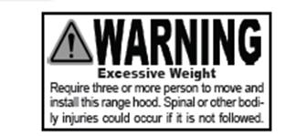
Advanced Preparations:
- Read the entire installation and user’s guide thoroughly and understand instructions and warnings.
- Be familiar with the controls of the range hood by reading through Range Hood Operations.
- Place the range hood on a flat, stable surface. Connect the range hood to a designated standard outlet (220-240 volt, 50Hz, AC only) and verify no debris has entered the vent openings, then turn on the range hood. Verify all operations of the range hood by referring to Range Hood Operations.
- Place all supplied parts and required hardware on a flat, stable surface and verify the existence of all supplied parts listed on Page 7
- Carefully remove the white plastic protective coat from the chimney covers and range hood.

Preparations:
- Determine and mark the center line on the ceiling where the range hood will be installed. Make sure there is proper clearance within the ceiling or wall for exhaust vent.
- Due to the weight and size of this unit, please make sure that the support system or framework being used is stable and secure in the ceiling.
- Put a thick, protective covering over counter top, cook top or range to protect from damage or dirt. Remove any hazardous objects around the area when installing.
- Mark the locations of the support mounting bracket holes, vent cutout (if used) and power supply cable cutout on the ceiling. Use drill and saber saw or keyhole saw to cut openings for power supply cable and vent (see Venting requirements and Electrical requirements)
- If venting to the outside install vent system (See Venting Requirements, Page 7). Use caulking to seal exterior wall or roof openings.
- Disconnect main electrical supply, prepare and run electrical wiring through ceiling. Leave approximately 12” of electrical cord hanging from the ceiling. Do not restore power until wiring is completed.
- Disconnect power cord, remove the aluminum filter by pressing on the latch and gently pull the baffle filter down.
- Set aside the aluminum filters until the range hood is properly installed.

SUPPLIED MATERIALS

Item | Quantity
Toggle Bolts | 6 Pcs
Body Hook | 1 Set
This Guide and Warranty Card | 1 Set
5x20 Screw | 20 Pcs
5x16x1 Shim | 16 Pcs
5x14x3 Shim | 4 Pcs

VENTING REQUIREMENTS

Vent system must terminate to the outside (roof or side wall), be careful not to bend duct as this will reduce the exhaust effectiveness of the rangehood.
- Do not terminate the vent system in an attic or other enclosed area.
- Do not use 102 mm laundry-type wall caps.
- Use metal/Aluminum vent only. Rigid metal/aluminum vent is recommended. Do not use plastic vent.
- Always keep the duct clean to ensure proper airflow.

Calculate the following figures before installation:
- Distance from the floor to the ceiling.
- Distance between the cooking surface to the range hood.
- Height of hood and duct cover.

For the most efficient and quiet operation:
- It is recommended that the range hood be vented vertically through the roof through with 2 x 200 mm round metal/aluminum vent work.
- The size of the vent should be uniform.
- Use no more than one 90°elbow.
- The vent system must have a damper. If roof or wall cap has a damper. Do Not use damper supplied with the range hood.
- Use duct tape to seal all joints in the vent system.
- Use caulking to seal exterior wall or roof opening around the cap.

VENTING METHODS

This range hood is factory set for venting through the roof or wall. It is not designed for reticulating. Vent work can terminate either through the roof or wall. To vent through a wall, a 90°elbow is needed.

IMPORTANT:
NEVER exhaust air or terminate duct work into spaces between walls, crawl spaces, ceiling, attics or garages. All exhaust must be ducted to the outside.
Use metal/aluminum duct work only.
Fasten all connections with sheet metal screws and tape all joints with certified Silver Tape or Duct Tape.

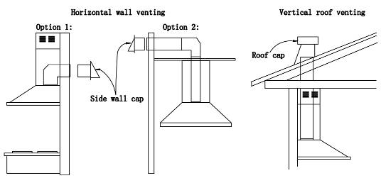
Use caulking to seal exterior wall or roof opening around the cap.

INSTALLATION
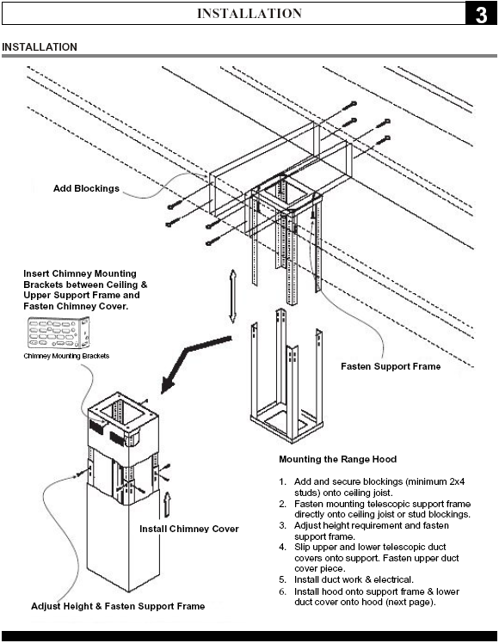

- A minimum of 2 x 200 mm round ducts (standard for this range hood) must be used to maintain maximum airflow efficiency.
- Flexible 200 mm round ducts are provided for convenience, always use rigid type metal/aluminum ducts if available to maximize airflow when connecting to provided duct.
- Please use Duct Run Calculation below to compute total available duct run when using elbow, transitions and caps
- ALWAYS, when possible, reduce the number or transitions and turns. If a reducer is used, install a long reducer instead of a pancake reducer. Reducing duct size will restrict airflow and decrease airflow, thus reduce duct size as far away from opening as possible.
- Minimum mount height between cooking surface to hood bottom should be no less than 120cm.
- Maximum mount height should be no higher than 135cm.
- It is important to install the hood at the proper mounting height. Hoods mounted too low could result in heat damage and fire hazard; while hoods mounted too high will be hard to reach and will lose its performance and efficiency.
- If available, also refer to manufacturer’s height clearance requirements and recommended hood mounting height above cooking surface.
Minimum Duct Size:
- Round 2 x 200 mm (minimum)

ELECTRICAL REQUIREMENTS

IMPORTANT:
Observe all governing codes and ordinances and save installation instructions for electrical inspector’s use.

It is the customer’s responsibility:
To contact a qualified electrical installer and ensure that the electrical installation is adequate and in conformance with Local Electrical Regulation.

- If codes permit and a separate ground wire is used, it is recommended that a qualified electrician determine that the ground path is adequate.
- A 220-240 volt, 50 Hz, AC-only, supply is required on a separate circuit.
- Do not ground to a gas pipe.
- Do not have a fuse in the neutral or ground circuit.
- RISK OF ELECTRICAL SHOCK. This range hood must be properly grounded. Check with a qualified electrician if you are not sure whether the range hood is properly grounded.
- The range hood should be connected directly to the fused disconnect (or circuit breaker) box through flexible armored or non-metallic sheathed copper cable. Do not use extension cord or adapter plug with this appliance.
- The range hood must be connected with copper wire/plug only.

RANGEHOOD OPERATION

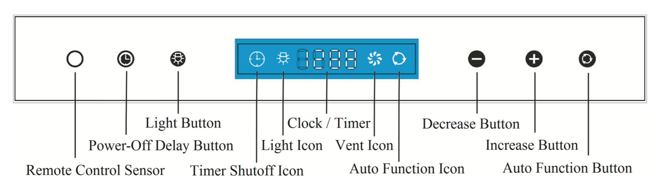
In addition to the remote control feature, this range hood is also equipped with a heat sensor that will self-calibrate in 5 seconds when the range hood is first electrically activated and beeps when self-calibration is done. To con- serve energy, the LCD panel will turn off automatically after 5 seconds of inactivity. For the best results, start the range hood before cooking and allow it to operate several minutes after the cooking is completed to clear all smoke and odors from the kitchen.
Activating Normal Blower Function:
•While the range hood is off, use the Increase or Decrease buttons to start the
blower. Press Increase button to increase blower speed (“F1” to “F3”) as indicated in LCD panel. The Increase button cycles blower settings from “off” (00), “low” speed (F1), “medium” speed (F2), “high” speed (F3)
•While the range hood is on and the blower is running, press Decrease button to decrease blower speed (“F3” to “F1”) as indicated in LCD panel. The Decrease button cycle blower settings from “high” speed (F3), to “medium” speed (F2), “low” speed (F1)
Adjusting Heat Sensitive Auto Speed (HSAS) Function:
•Press the Auto Function button to turn On/Off the Auto Mode. The Auto Function
Icon will illuminate in the LCD Panel when Auto Mode is On.
•While the range hood is off, press and hold Auto Function button to enter the
temperature setting mode. Use the Increase or Decrease button to adjust the comparison temperature value between the internal and external heat sensors from “8°” to “20°” (these values are not exact measurements but are level settings). The temperature setting mode will exit automatically after 5 seconds of inactivity.
•While the range hood is off and Auto Function is activated, the blower will turn on to its highest speed automatically when the internal temperature is 4 times above the external temperature. It will then adjust the speed level (between F3 to F1) automatically according to the detected temperature between the sensors (4 times to 1 time). The automatic speed level can be manually overwritten by pressing the Increase or Decrease button and then Auto Function will reactivate after 2 minutes. The blower can ONLY be turned off MANUALLY or by activating the Power-Off Delay Timer Function.

Activating Light Function:
•Press Light button once to turn on the lights, and once again to turn off the lights.
CAUTION: DO NOT touch the lights or surrounding surface until turned OFF and allowed to cool.
Activating Power-Off Delay Function:
•While the range hood is on and the blower is running, press Power-Off Delay
button to activate delay off timer and “Timer Shutoff” icon will appear in LCD panel. Adjust to desired period of delay off timer by pressing Increase or Decrease button (minimum 1 minute to maximum 15 minutes). Timer begins to countdown immediately, when it reaches 0, the blower will shut off.
Adjusting Clock Function:
•While the range hood is off, press Power-off Delay button once to enter the clock
setting mode; use the Increase or Decrease button to set the Hours column; press the Power-off Delay button again to set the Minutes column; press the Power-off Delay button again to exit the clock setting mode.
Remote Control Sensor:
•Remote control sensor receives infrared (“IR”) signal from the remote control. The
maximum distance for IR data transmission is about 3 meter (10 ft.) and requires direct line of sight. The transmission distance may vary depending on temperature and remote control battery condition.
Note: Light settings are independent from other settings (including power-off delay) and are required to be manually turned on or off.

CLEANING

The saturation of greasy residue in the blower and filters may cause increased inflammability. Keep unit clean and free of grease and residue build-up at all times to prevent possible fires.

Filters must be cleaned periodically and free from accumulation of cooking residue (see cleaning instructions inside). Old and worn filters must be replaced immediately. Do not operate blowers when filters are removed. Never disassemble parts to clean without proper instructions.

Easiair declines all responsibility in the event of failure to observe the instructions given here for installation, maintenance and suitable use of the product.
Easiair further declines all responsibility for injury due to negligence and the warranty of the unit automatically expires due to improper maintenance.

SPECIFICATIONS

Specifications*:
Body | 316 Marine Grade Stainless Steel
Power Rating | 220-240V/50Hz
General Input Power | 520W
Motor Input Power | 2 * 253W
Levels Of Speed Control | 3 Levels
Maximum Airflow | 2 * 1832 M³/H
Noise Level(dB/sone) | Approximately 20- 60 (Lowest to highest Speed)
Motor Type | Double Chamber Ultra Quiet
Control Type | Touch Controls with Remote
Illumination | LED X 4 X 3.5 Watt white color Lights
Venting Size | 2 x 200mm Round

TROUBLE SHOOTING

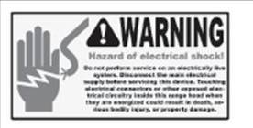

- If the range hood does not operate after installation:

Check if the range hood has been plugged in, make sure that all power has been turned on and all electrical wiring are properly connected.
Swap out light assembly to working ones to determine whether it is caused by defective bulbs (See replacing the light bulbs)

- The range hood vibrates when the Rangehood is on:

The range hood might not have been secured properly on to the ceiling

- The Suction seems weak:

Check that the duck sizes used are at least 2 x 150 mm. Rangehood WILL NOT function efficiently with insufficient duct size. For example: 200 mm hole and loosely secured.
Check if duct is clogged or if damper unit is not opening properly. A tight mesh on a side, wall cap unit might also cause restriction to the air flow. Ensure ducting is free of multiple bends. More than one 90° bend will cause restriction of the air flow.

- The lights work but the blower is not spinning at all, is stuck or is rattling.

The blower might be jammed or scraping the bottom due to shipping damage.

5. The hood is not venting out properly.

Make sure the distance between the cook top and the bottom of the hood is within 120mm and 1350 mm in range. Ensure there is only 1 elbow or bend in the ducting. Check if all joints are properly connected, sealed, and taped. Make sure the power is on high speed for heavy cooking.

WARRANTY TERMS AND CONDITIONS

The Easiair Range Hood is covered by a 24 month warranty for parts failure. Warranty does not cover installation faults. If the range hood is not installed by a qualified installer, the warranty may be revoked.
This warranty covers repair and replacement of spare parts excluding light bulbs for a period of 24 months from date of purchase. All receipts must be presented when claiming warranty.

For all warranty claims please contact-
Rangehoods Plus Pty Ltd
PO Box 573, Ashburton VIC 3147
Phone: 1300 912 864
Email: info@rangehoodsplus.com.au

